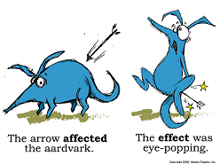

What Is the Difference Between Affect and Effect?

The majority of the time you use affect with an a as a verb and effect with an e as a noun.

When Should You Use Affect?

Affect with an a means "to influence," as in, "The arrows affected Ardvark," or "The rain affected Amy's hairdo." Affect can also mean, roughly, "to act in a way that you don't feel," as in, "She affected an air of superiority."

When Should You Use Effect?

Effect with an e has a lot of subtle meanings as a noun, but to me the meaning "a result" seems to be at the core of all the definitions. For example, you can say, "The effect was eye-popping," or "The sound effects were amazing," or "The rain had no effect on Amy's hairdo."

